Tatton Wildlife Newsletter – Autumn

Autumn is the time of preparation as the natural world looks towards the leaner, darker days of winter. Strategies for survival are employed, whether it be squirrels gathering nuts, bird migration or mammals moulting to a winter coat for warmth. The spectacular autumn colours and colder misty mornings are fantastic to experience in the parkland.
Deer
The autumn deer rut is a privilege to witness. The males split away from each other, dig out muddy scrapes in the ground with hoof and antler to wallow in. They adorn their antlers with grass to make themselves look more intimidating. The red deer stag bellows to attract hinds and to warn away rivals, as he battles to keep his harem together. The fallow deer bucks have a rasping, snorting call and he employs the different tactic of holding a territory called a ‘stand’. If all the intimidating behaviour fails, the last resort is the clashing of antlers. They are locked in a battle of strength where the bigger, stronger male will triumph, and the superior genes will be passed on to the herd. Please keep your distance from the deer as any disturbance interferes with their natural behaviour. We recommend 50m where possible. They will need to stay in good condition, not only ready for the onset of winter but also for the energy exerted during rutting season. The males barely eat during this time and will need to recover quickly.
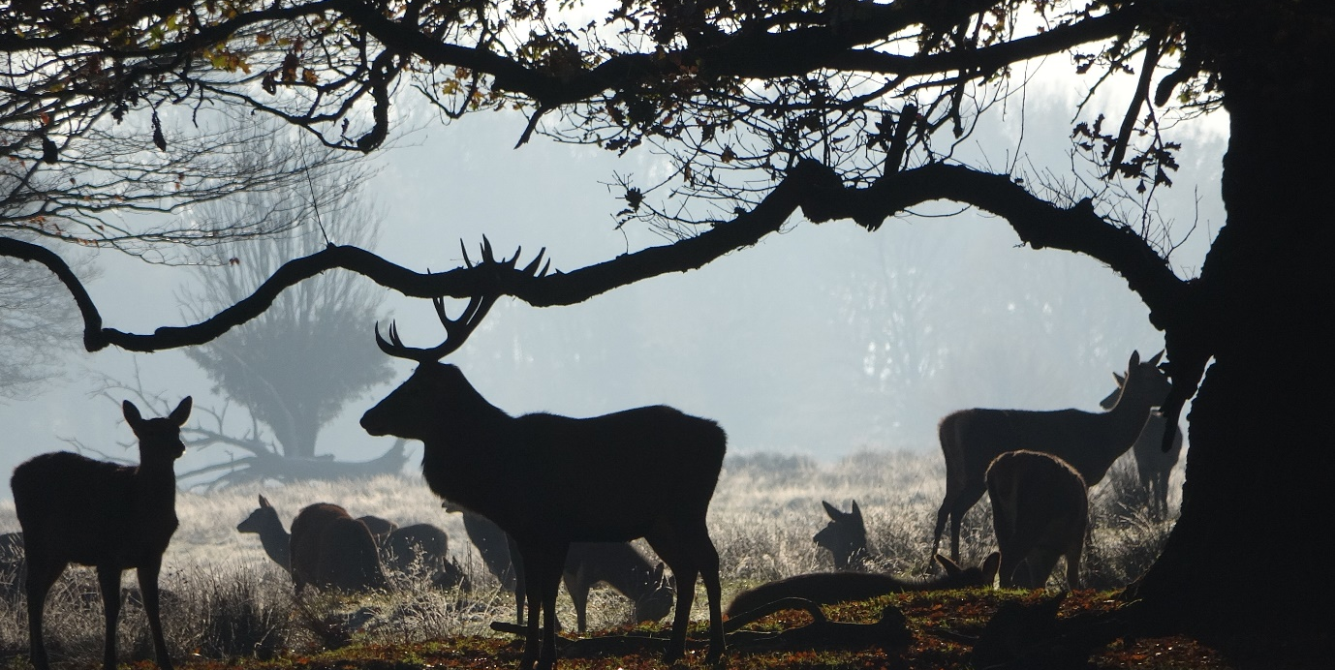
Birds
Bird migration takes place during autumn. Our summer visitors leave us and we are joined by visitors from the north. Thrushes such as redwing and fieldfare arrive from Scandinavia and the number and variety of wildfowl on the meres increase. Passing autumn migrants could include wheatears, hobbies or maybe a late moving osprey passing over.
Recent interesting sightings included a spotted flycatcher and wheatear. Also, two shelduck with two chicks on Melchett Mere and three terns over Tatton mere. A group of ring-necked parakeets flying over the park in June was an unusual sight here. Although they are now common in parks in nearby South Manchester, they have yet to get a foothold at Tatton, but it is only a matter of time.
Bats
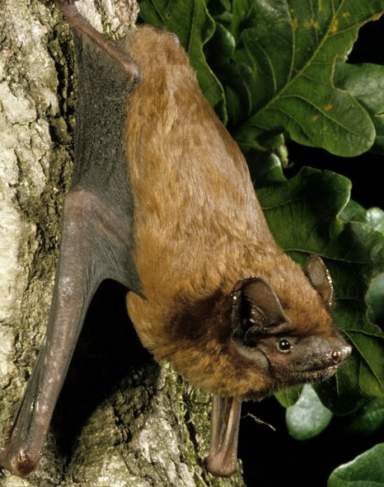
Bats are quite active at this time of year. The young ‘pups’ are now fully grown and are on the wing feeding along with the adults. The estate team managed to find a noctule roost in Boathouse Wood. They were alerted by the loud squeaking noises emanating from a crack in an oak tree. Noctules are one of Britain’s largest bats and are often very vocal within the roost. Urine stains on the trunk can be another indicator of a roost, but nevertheless it is quite rare to spot an active bat roost in a tree, particularly as bats very often move between them quite regularly. South Lancs. Bat Group used night vision cameras to film the noctules emerging and counted 58, surpassing the previous best of 47, so Tatton is clearly an area where they do well.
Fungi
Tatton can boast many species of interesting fungi and they are crucial to finely balanced ecosystems. From a gigantic bracket fungus, a host specific species in the shadow of a tree to a tiny dot on a leaf, each has a role to play. Why not join us on our Fungal Foray to find out more?

Compiled by Tatton’s Ranger Team

